## AGSN Developer Manual

This document mainly explains how the features in the AGSN is implemented.

### Plugin.xml and extension point

To add new user action to the editor, developer should modify the plugin.xml. Open the tab “Extensions”, developer can see all the extensions. To add new feature, developers should first define a new command under the “org.eclipse.ui.commands”. Then developers should create the menu to show the feature (if the feature is acted via menu). The created menu should point to the corresponding command. At the end, developers should create a handler for the feature wherein the path of the Java class is given. The handler should also point to the corresponding command.

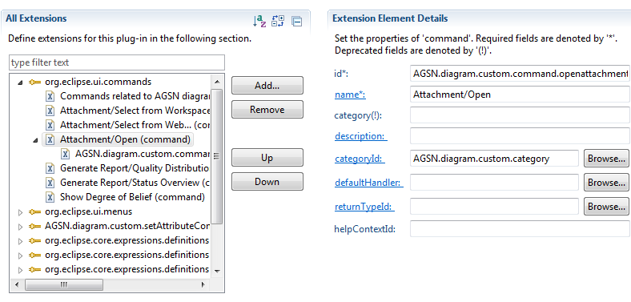

Figure 1: The command of Attachment/Open

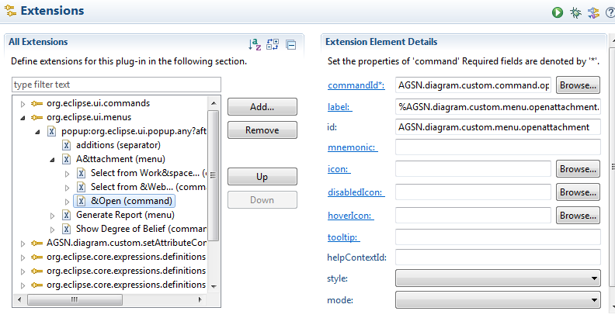

Figure 2. The menu of Attachment/Open

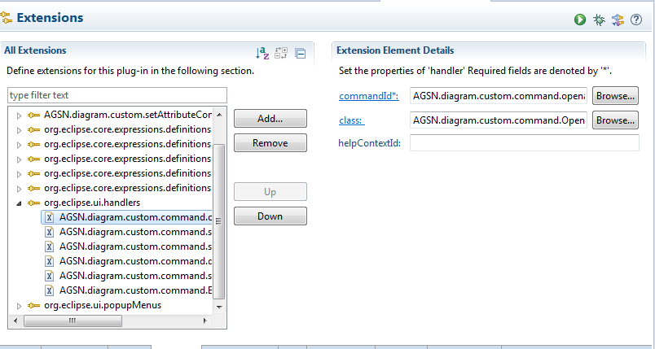

Figure 3. The handler of Attachment/Open

For example, the command for the menu Attachment -> open is defined in Figure 1. Then the menu is defined in Figure 2. The handler is defined in Figure 3.

### Features Implementation

In this section, all the related commands, menu info and handlers for each feature are listed.

#### Attachment

Select attachment from workspace:

|  |  |
| --- | --- |
| Command ID | AGSN.diagram.custom.command.selectattachmentfromws |
| Menu ID | AGSN.diagram.custom.menu.selectattachmentfromws |
| Handler Class | AGSN.diagram.custom.command.SelectAttachmentFromWSHandler |

Select attachment from web:

|  |  |
| --- | --- |
| Command ID | AGSN.diagram.custom.command.selectattachmentfromweb |
| Menu ID | AGSN.diagram.custom.menu.selectattachmentfromweb |
| Handler Class | AGSN.diagram.custom.command.SelectAttachmentFromWebHandler |

Open attachment:

|  |  |
| --- | --- |
| Command ID | AGSN.diagram.custom.command.openattachment |
| Menu ID | AGSN.diagram.custom.menu.openattachment |
| Handler Class | AGSN.diagram.custom.command.OpenAttachmentHandler |

#### Assessment status (Change BG color)

The background colour of the element will be changed when the assessment status is changed. This is implemented by modifying *XXXEditPart.java* in the project *AGSN.diagram* under the package *AGSN.diagram.edit.parts*. The method *handleNotificationEvent*, *GoalFigure()* and *updateBGColor()*.

|  |  |
| --- | --- |
| Goal | GoalEditPart.java |
| Context | ContextEditPart.java |
| Assumption | AssumptionEditPart.java |
| Contract | ContractEditPart.java |
| Evidence | EvidenceEditPart.java |
| Justification | JustificationEditPart.java |
| Module | ModuleEditPart.java |
| Strategy | StrategyEditPart.java |
| Additional element | AdditionalElementEditPart.java |

#### Generate report

Quality distribution:

|  |  |
| --- | --- |
| Command ID | AGSN.diagram.custom.command.qualitydistribution |
| Menu ID | AGSN.diagram.custom.menu.qualitydistribution |
| Handler Class | AGSN.diagram.custom.command.QualityDistributionHandler |

Status overview:

|  |  |
| --- | --- |
| Command ID | AGSN.diagram.custom.command.statusdistribution |
| Menu ID | AGSN.diagram.custom.menu.statusdistribution |
| Handler Class | AGSN.diagram.custom.command.StatusDistributionHandler |

#### ER score

Calculation: to implement this feature, we create a menu for the safety case separately. The other menus are showed, when an individual element is selected. But this menu is activated when user selects the safety case canvas. Therefore, this extension is different than others.

|  |  |
| --- | --- |
| Object | AGSN.diagram.custom.objectContribution.SafetyCaseEditPart |
| Object class | AGSN.diagram.edit.parts.SafetyCaseEditPart |
| Handler Class | AGSN.diagram.custom.command.CalculateERScoreAction |

Show ER degree in bar chart:

|  |  |
| --- | --- |
| Command ID | AGSN.diagram.custom.command.ERBarchart |
| Menu ID | AGSN.diagram.custom.menu.showER |
| Handler Class | AGSN.diagram.custom.command.ERBarchartHandler |

### Interfaces of AGSN.custom package and AGSN package

In the customized plugin project, the following interfaces are used to modify the model in the *AGSN* package.

|  |  |  |
| --- | --- | --- |
| Name | Description | Provided by |
| Selected element | Get the selected node of an event | AGSN.diagram.custom.command.AbstractEditPartHandler.java |
| Model instance | Get all the nodes, links and their relations in a model instance. | LinkManager |
| IFile | Get the diagram file of the current model. | AGSN.diagram.custom.AGSNEditorUtil |